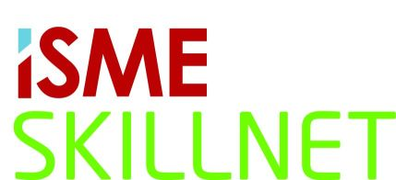
2015-YEAR OF RECOVERY
Briefing Sessions 2015

Ireland 2015. What is the economic forecast?
Jim Power, Economist and author.
- What are the general trends?
- How will these affect my business?
- Interest rates, Inflation, employment trends.
Learn how LEAN can make you more profitable.
Shane Hughes, MD, Lean Unlimited.
- Companies that engaged in ‘Lean Business’ increased productivity by €37,000 per employee (based on sales per employee).
- The programme had a 40% positive impact on sales and 11% increase in employment.
- Delivery schedule adherence (+42%), product/service quality & customer relationships (+30%).
- 72% agreed that Lean programme helped their company to weather the negative consequences of the recent economic downturn.
Employment Law Update.
Mark Fielding, CEO, ISME.
- Recruitment, retention, absenteeism.
- Maternity, Paternity, Parental leave.
- Contracts, permanent, part-time, fixed term. How flexible?
- New procedures.
Government & Other Assistance for your Business.

- Employment schemes.
- Financial supports
And much more.

27.01.15 | Dundalk | Crowne Plaza Hotel | 10.00am - 1.00pm
27.01.15 | Dublin West | Red Cow Moran Hotel | 6.00pm - 9.00pm
03.02.15 | Kilkenny | Hotel Kilkenny | 10.00am - 1.00pm
03.02.15 | Cork | Silversprings Hotel | 6.00pm - 9.00pm
04.02.15 | Killarney | Brehon Hotel | 10.00am - 1.00pm
04.02.15 | Limerick | Strand Hotel | 5.30pm - 8.30pm
11.02.15 | Sligo | Clarion Hotel | 5.30pm - 8.30pm
12.02.15 | Dublin South | Stillorgan Park Hotel | 6.00pm - 9.00pm

All sessions are FREE but booking is essential
Please return booking form to ISME, 17 Kildare Street, Dublin 2
Name: | Company: | Email: | Mobile No: | Venue:

Fax: (01) 6612157 Email: info@isme.ie
Online Booking: www.isme.ie

